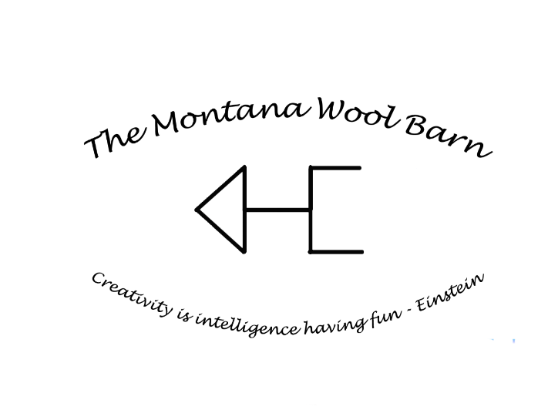
-------------------------------------------------------------------------------------------------------------------------------
*50% deposit required prior to processing. The remainder due at time of pickup/shipment. Any orders left unpaid for 60 days will become the property of The Montana Wool Barn.
Name________________________________________________________________________________
Address______________________________________________________________________________
Phone__________________________________________________
Email___________________________________________________
_____________________________________________________________________________________
Fiber information
Animal name____________________________________ Color____________________________
Fiber type ____________________________________________________________________________
Incoming Weight_________________________________

Desired processing
(Circle one)
Roving Batts Core Rug Yarn Pin Draft Spinning Needle Felting

Special instructions/comments. ________________________________________________________________________________________________________________________________________________________________________________________________________________________________________________________________________________________________________________________________________________________________________________________________________________________________________________________________________________________________________________________________________________________________________________________________________________________________________________________________________________________________________

